Great question — these three often look similar but operate at different levels of abstraction. Let’s break them cleanly so you can mentally separate system design vs runtime behavior vs internal mechanics.

🧠 1. Big Picture Difference
Section | What it Represents | Level
2. End-to-End Flow | Simplified pipeline view | 🟢 High-level (architecture summary)
3. Step-by-Step Architecture Flow | Internal components of the model | 🔵 Deep system design
5. Inference Flow | Runtime execution loop | 🔴 Dynamic behavior

🔄 2. End-to-End Flow (Simple View)
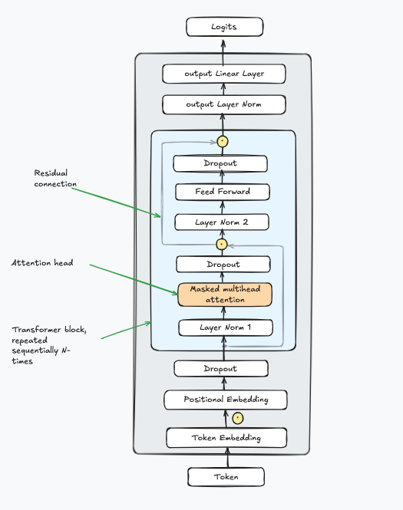
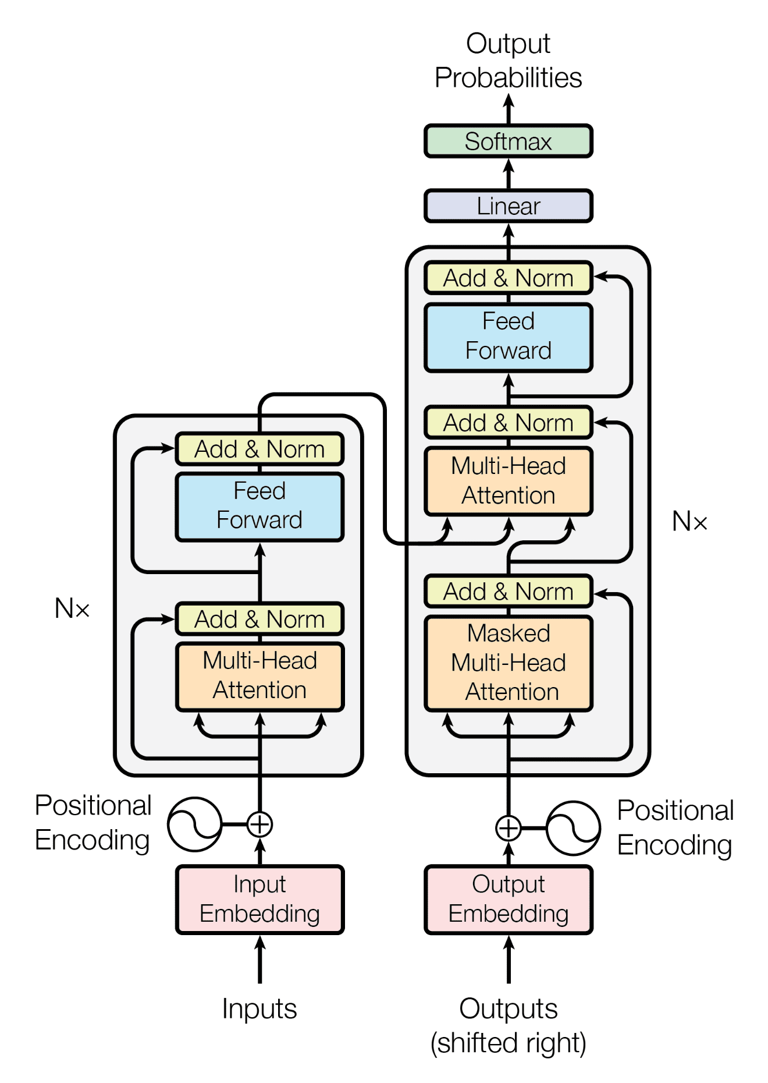
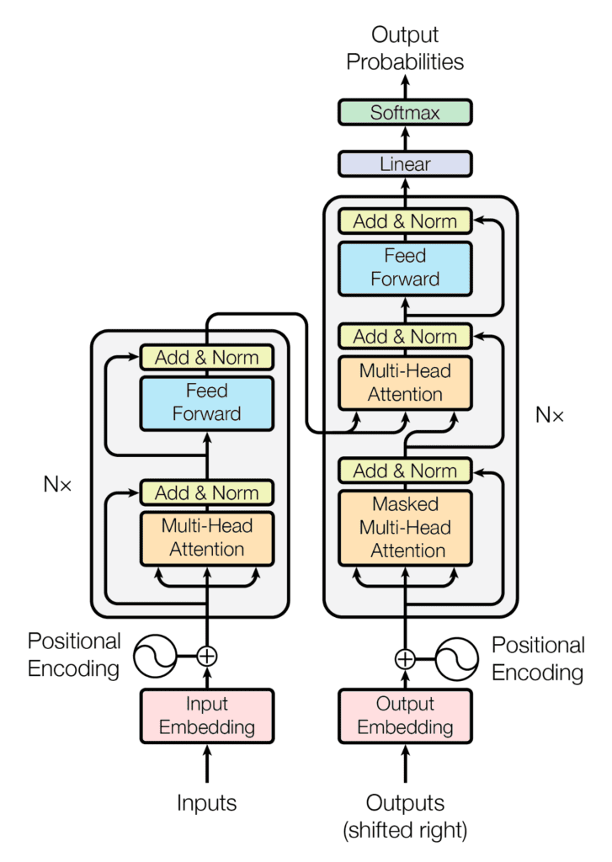
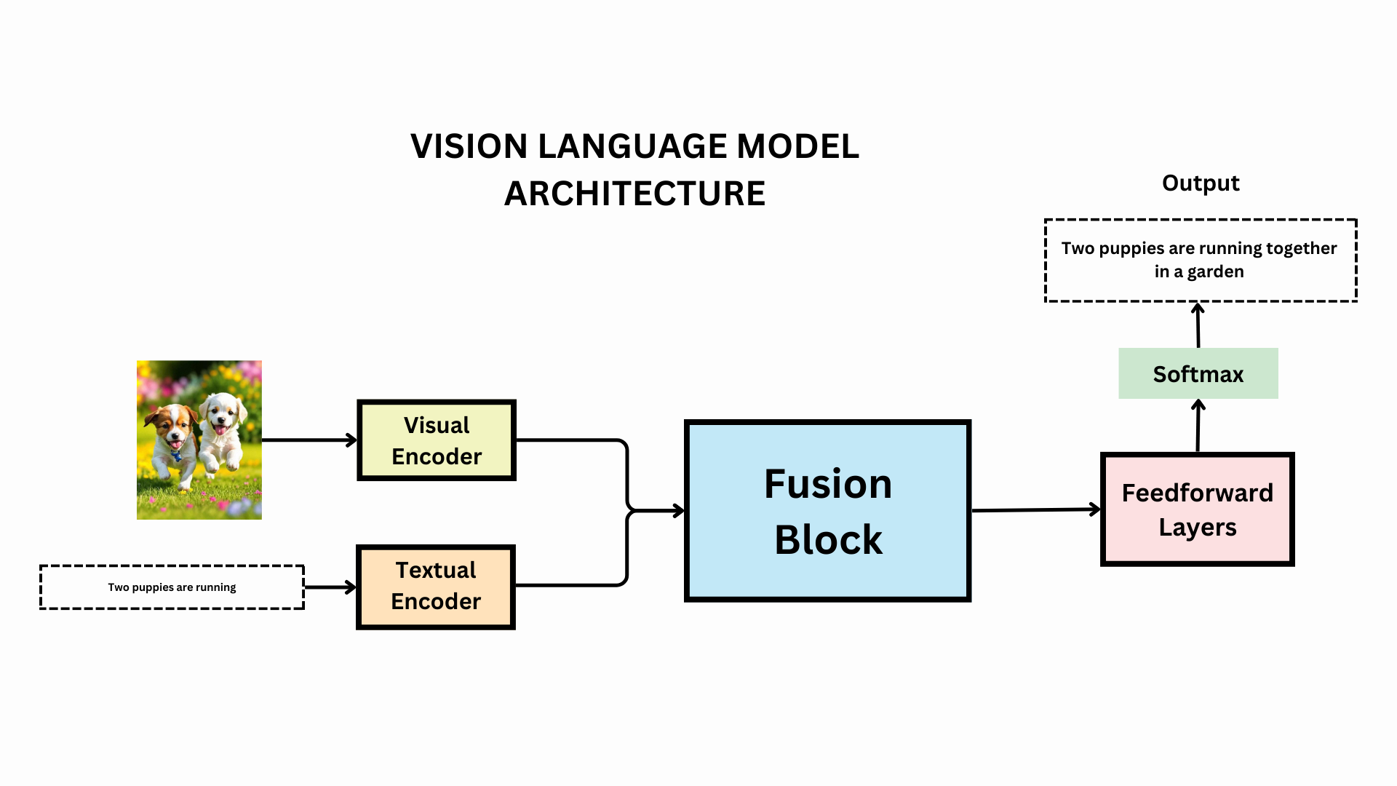
This is the “10,000-foot view” — like an architecture diagram in a design doc.
Input → Tokenization → Embeddings → Transformer → Logits → Softmax → Output

🔑 Purpose:
- Explain what stages exist
- Not concerned with internal math or loops

🧠 Analogy:
Like saying:
“A web request goes → API → Service → DB → Response”

🧩 3. Step-by-Step Architecture Flow (Inside the Model)

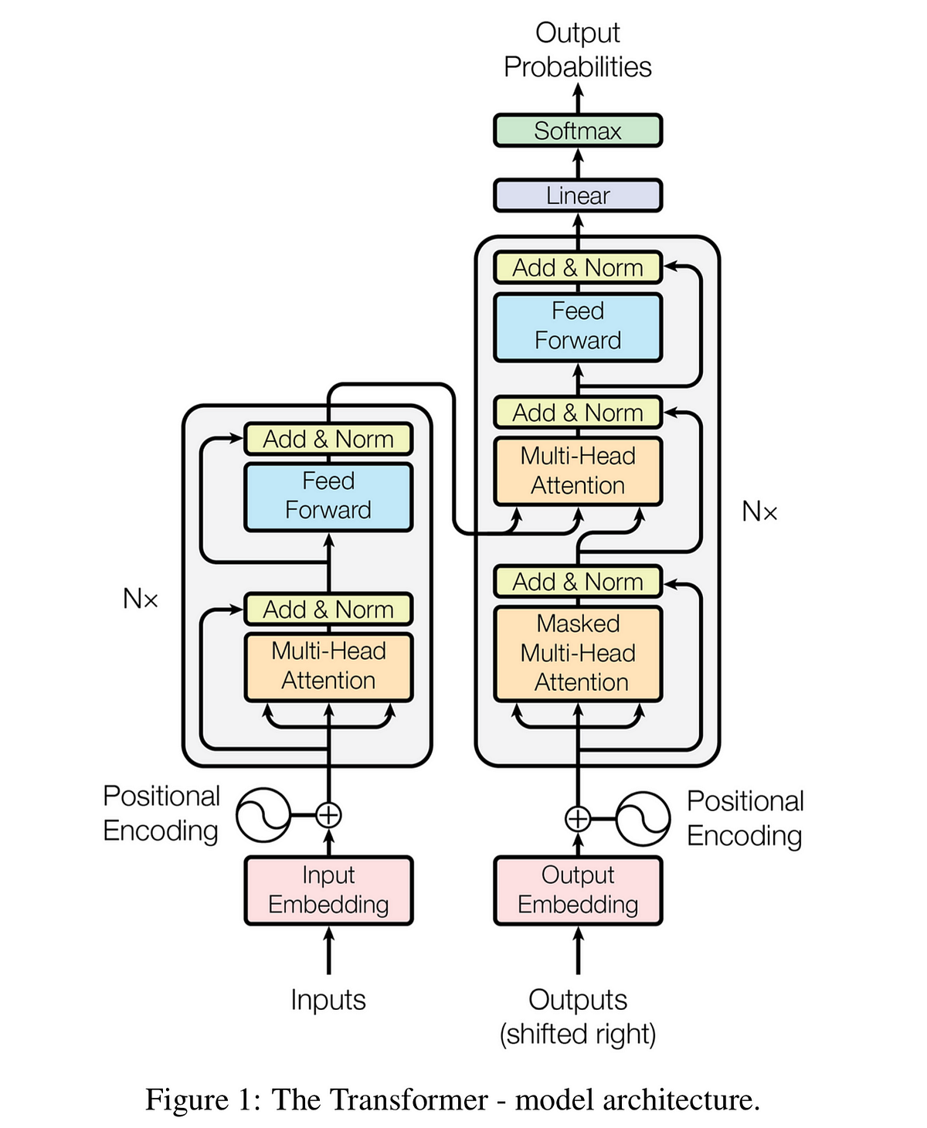

This is the “how each box works internally”
Instead of just “Transformer”, we open it:

Inside Transformer:
- Masked Self-Attention (Q, K, V)
- Multi-head attention
- Feedforward network
- Residual connections
- Layer normalization

🔑 Purpose:
- Explain how the model thinks
- Focus on math + internal data flow

🧠 Analogy:
Instead of:
“Service processes request”
Now you explain:
“Service has validation → business logic → caching → DB calls → retry logic”

⚡ 5. Inference Flow (Runtime Behavior)
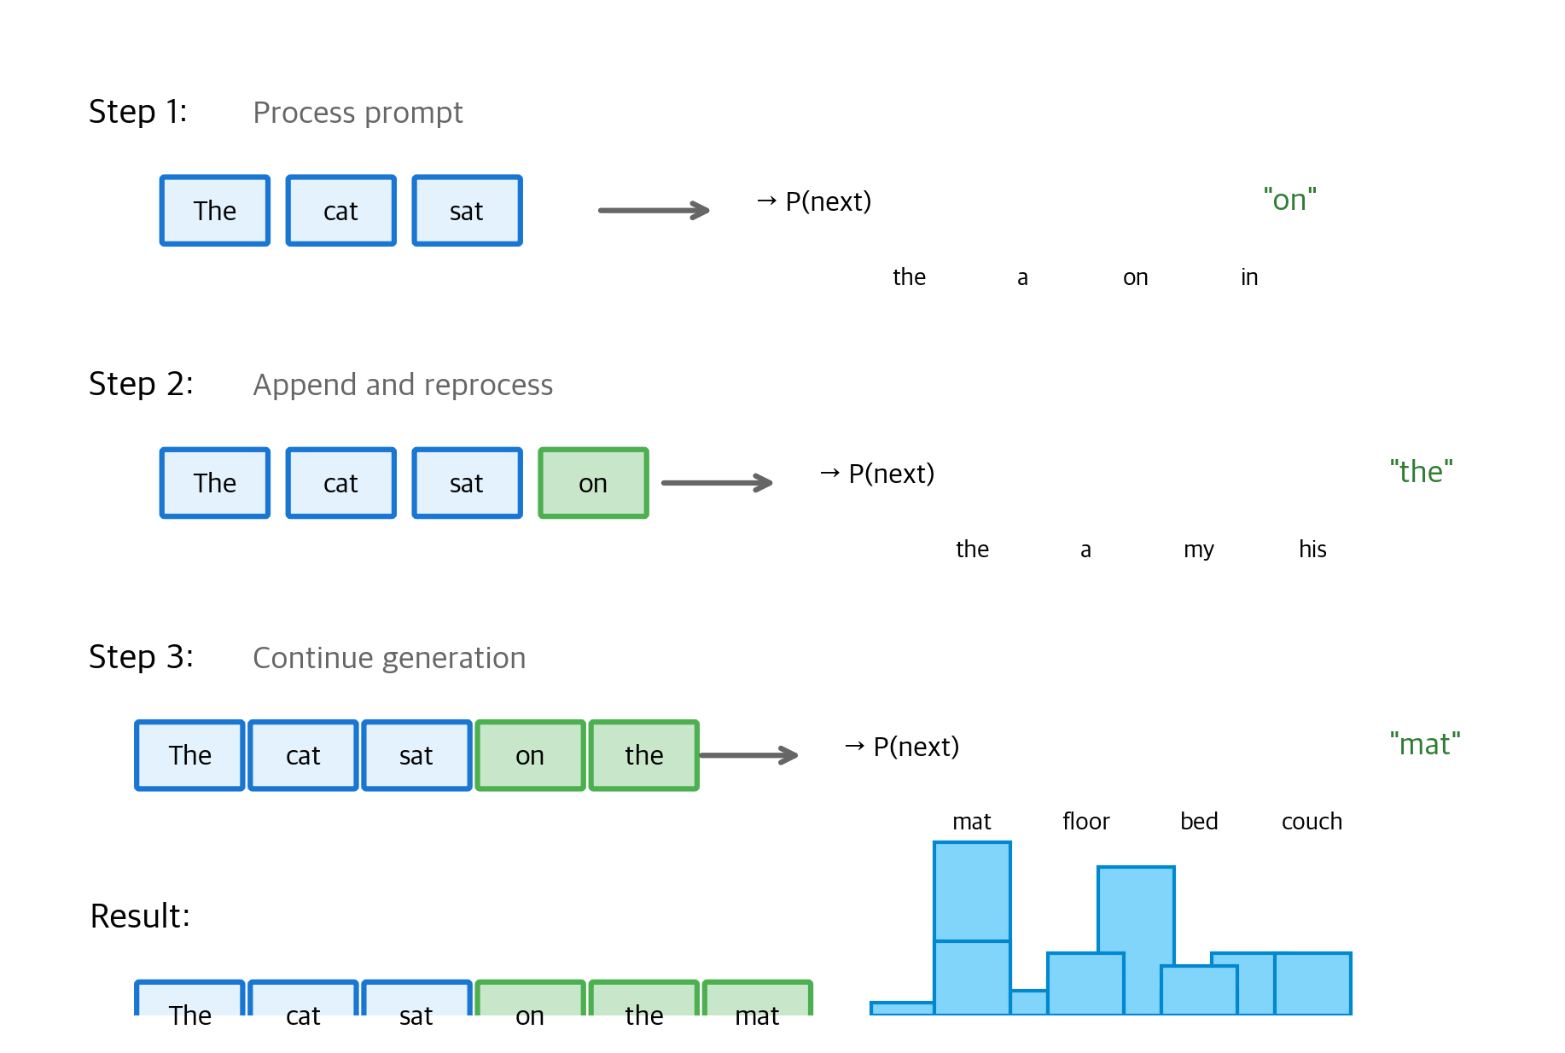
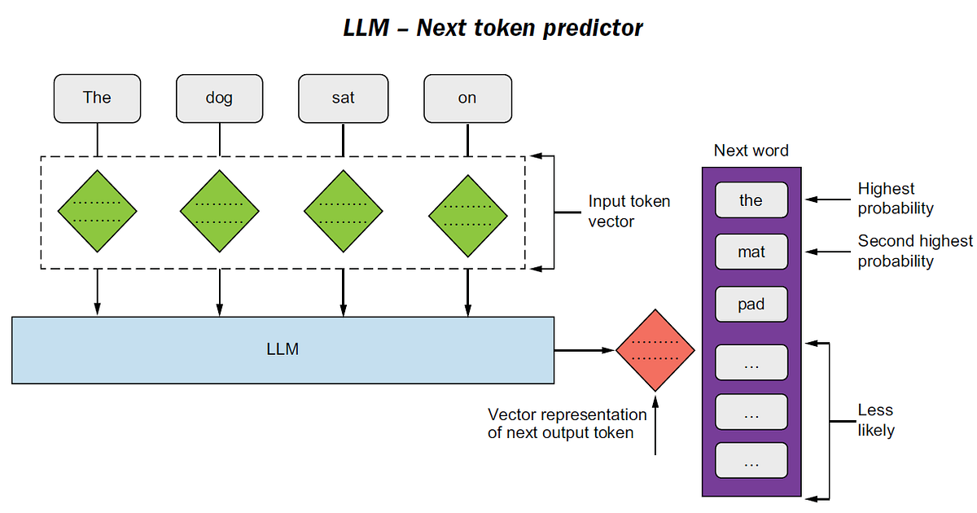
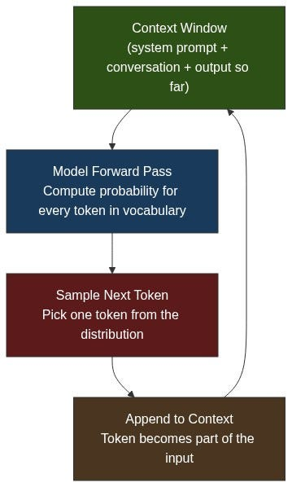
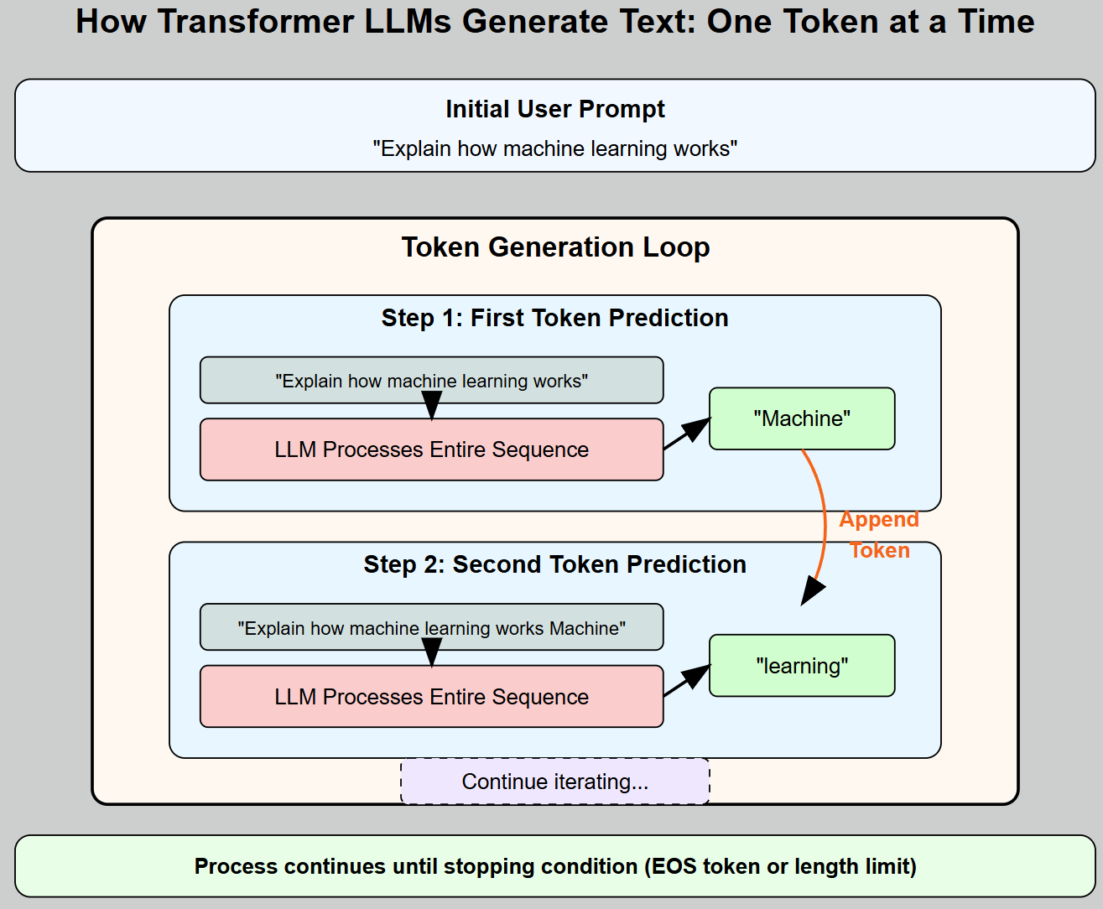
This is what actually happens when you type a prompt.

🔁 Core Idea: LOOP
Input → Predict next token → Append → Repeat

Step-by-step runtime:
- You type prompt
- Model processes full input
- Predicts next token
- Adds it to sequence
- Runs again with updated input
- Continues until stop

🔑 Purpose:
- Explain execution over time
- Not architecture, but behavior

🧠 Analogy:
Like:
“While user is connected → keep sending streamed responses”

🧠 Final Mental Model (VERY IMPORTANT)
Think in 3 layers:

🟢 Layer 1 — Pipeline (Section 2)
What are the stages?

🔵 Layer 2 — Engine Internals (Section 3)
How does each stage work internally?

🔴 Layer 3 — Runtime Loop (Section 5)
How does the system behave over time?

🔥 Super Clear Comparison
Aspect | End-to-End Flow | Step-by-Step Architecture | Inference Flow
Focus | Pipeline | Internal mechanics | Runtime execution
Depth | Low | Very deep | Medium
Time dimension | ❌ No | ❌ No | ✅ Yes (loop)
Used by | Architects | AI engineers | System/runtime engineers
Example | Input → Output | Q/K/V math | Token-by-token generation

🚀 How You Should Think (Architect Mindset)
Since you're a system architect, map like this:
- End-to-End Flow → System architecture diagram
- Step-by-Step → Component design (low-level design / LLD)
- Inference Flow → Runtime sequence diagram

⚡ One-line Summary
End-to-End = WHAT pipeline
Step-by-Step = HOW it works internally
Inference = HOW it runs over time

If you want next level clarity, I can:
- Merge all 3 into a single unified diagram
- Show exact data structures at each step (tensor shapes)
- Walk through a real token example numerically
Just tell me 👍

